Common Estimation Techniques

Estimation Techniques

1. Work Breakdown Structure (WBS)
# Source: AI Source: Provided by: [Data Path: Persons Table -> ID Column: 1, Name_En Column: Motasem Essam] -> From: [ChatGPT] on [8/24/2025]
- Testing tasks are broken down into smaller sub-tasks.
- Estimate each sub-task → then add them up.
✅ Example:
- Test Planning = 8 hrs
- Test Case Design = 20 hrs
- Test Execution = 40 hrs
- Defect Retesting = 12 hrs
- Total = 80 hrs

2. Expert Judgment
# Source: AI Source: Provided by: [Data Path: Persons Table -> ID Column: 1, Name_En Column: Motasem Essam] -> From: [ChatGPT] on [8/24/2025]
- Estimation based on the experience of senior testers or managers.
- Useful when similar projects were done before.
✅ Example:
- A test manager recalls a similar e-commerce project took ~200 hrs.
- Adjusts based on new complexity → 220 hrs.

3. Three-Point Estimation (PERT Technique)
# Source: AI Source: Provided by: [Data Path: Persons Table -> ID Column: 1, Name_En Column: Motasem Essam] -> From: [ChatGPT] on [8/24/2025]
Uses 3 values to calculate realistic estimates:
- O (Optimistic) – best case
- M (Most Likely) – normal case
- P (Pessimistic) – worst case
Formula:
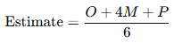
Estimate=O+4M+P6\text{Estimate} = \frac{O + 4M + P}{6}
✅ Example:
- O = 10 hrs, M = 15 hrs, P = 30 hrs
- Estimate = (10 + 4×15 + 30) ÷ 6 = 16.67 hrs

4. Function Point Analysis (FPA)
# Source: AI Source: Provided by: [Data Path: Persons Table -> ID Column: 1, Name_En Column: Motasem Essam] -> From: [ChatGPT] on [8/24/2025]
- Estimates effort based on functionality size (inputs, outputs, user interactions, files, etc.).
- More functionality → more testing effort.
✅ Example:
- Login (5 pts), Payment (10 pts), Reporting (15 pts).
- Total = 30 Function Points → 3 hrs per FP = 90 hrs testing.

5. Use Case Point (UCP)
# Source: AI Source: Provided by: [Data Path: Persons Table -> ID Column: 1, Name_En Column: Motasem Essam] -> From: [ChatGPT] on [8/24/2025]
- Similar to FPA but based on use cases.
- Factors in complexity of actors & transactions.
✅ Example:
- Simple Actor = 1 pt, Complex Actor = 3 pts.
- Simple Use Case = 5 pts, Complex Use Case = 15 pts.
- Multiply by productivity factor → final estimate.

6. Test Point Analysis
# Source: AI Source: Provided by: [Data Path: Persons Table -> ID Column: 1, Name_En Column: Motasem Essam] -> From: [ChatGPT] on [8/24/2025]
- Special for test cases.
- Effort is based on number of test cases × complexity factor.
✅ Example:
- 100 test cases × 1 hr each = 100 hrs.
- If 20% are complex → +20 hrs.
- Total = 120 hrs.

7. Wideband Delphi Technique
# Source: AI Source: Provided by: [Data Path: Persons Table -> ID Column: 1, Name_En Column: Motasem Essam] -> From: [ChatGPT] on [8/24/2025]
- A group of experts give estimates independently.
- Then discuss differences and refine until consensus is reached.
✅ Example:
- Expert A: 150 hrs, Expert B: 200 hrs, Expert C: 180 hrs → After discussion, agree on 185 hrs.

8. Matrix-Based Technique
# Source: AI Source: Provided by: [Data Path: Persons Table -> ID Column: 1, Name_En Column: Motasem Essam] -> From: [ChatGPT] on [8/24/2025]
Uses a matrix of features/modules vs. complexity/risk levels to assign effort.
✅ Example:
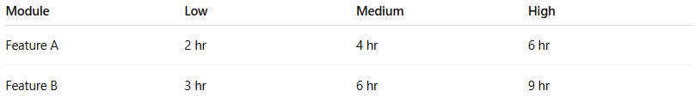
Module | Low | Medium | High
Feature A | 2 hr | 4 hr | 6 hr
Feature B | 3 hr | 6 hr | 9 hr
If Feature A = High → 6 hrs, Feature B = Medium → 6 hrs → Total = 12 hrs

9. Ratio-Based Estimation
# Source: AI Source: Provided by: [Data Path: Persons Table -> ID Column: 1, Name_En Column: Motasem Essam] -> From: [ChatGPT] on [8/24/2025]
Uses historical ratios between development and testing from similar projects.
✅ Example:
Previous project ratio = 1:0.4 (Dev:Test)
If Dev = 1000 hrs → Testing = 400 hrs

10. Extrapolation Estimation Technique
# Source: AI Source: Provided by: [Data Path: Persons Table -> ID Column: 1, Name_En Column: Motasem Essam] -> From: [ChatGPT] on [8/24/2025]
Uses actual completed work to estimate remaining effort.
✅ Example:
First 50 test cases = 80 hrs → For 200 cases →
Estimate = (80 ÷ 50) × 200 = 320 hrs

11. Percentage of Development Effort
# Source: AI Source: Provided by: [Data Path: Persons Table -> ID Column: 1, Name_En Column: Motasem Essam] -> From: [ChatGPT] on [8/24/2025]
- Testing is estimated as a fixed percentage of development time.
✅ Example:
- If development = 1000 hrs, testing = 30% → 300 hrs.

Scenario Used for All Techniques
# Source: AI Source: Provided by: [Data Path: Persons Table -> ID Column: 1, Name_En Column: Motasem Essam] -> From: [ChatGPT] on [8/24/2025]
🔥 Perfect! I’ll create a comprehensive side-by-side comparison table where all 11 estimation techniques are applied to the same project scenario.
- Project: E-commerce Website
- Development Effort: 1,000 hrs
- Modules: Login, Product Catalog, Payment, Reports
- Complexity Assumptions:
  - Login → Low
  - Product Catalog → Medium
  - Payment → High
  - Reports → High
- Total Test Cases: 200
- Complexity Mix: 20% complex
- Productivity Factor: 20 hrs per Use Case Point
- Function Points: Login (5), Payment (10), Reports (15) = 30 FP
- Use Case Points: 40 UCP

✅ Comparison Table (All 11 Techniques)
# Source: AI Source: Provided by: [Data Path: Persons Table -> ID Column: 1, Name_En Column: Motasem Essam] -> From: [ChatGPT] on [8/24/2025]
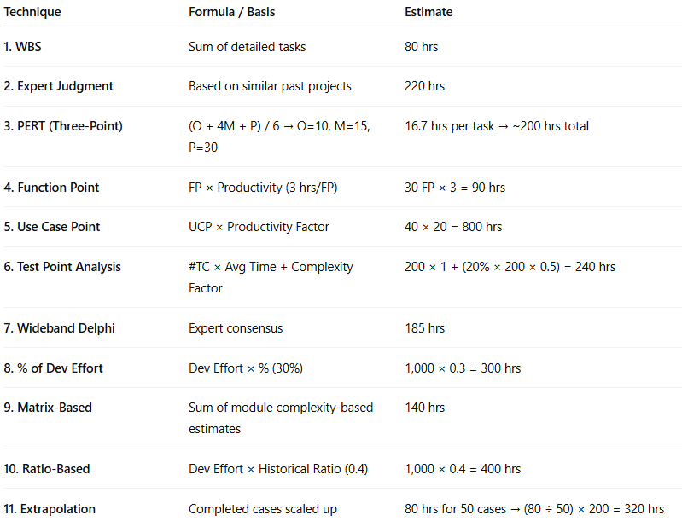
Technique | Formula / Basis | Estimate
1. WBS | Sum of detailed tasks | 80 hrs
2. Expert Judgment | Based on similar past projects | 220 hrs
3. PERT (Three-Point) | (O + 4M + P) / 6 → O=10, M=15, P=30 | 16.7 hrs per task → ~200 hrs total
4. Function Point | FP × Productivity (3 hrs/FP) | 30 FP × 3 = 90 hrs
5. Use Case Point | UCP × Productivity Factor | 40 × 20 = 800 hrs
6. Test Point Analysis | #TC × Avg Time + Complexity Factor | 200 × 1 + (20% × 200 × 0.5) = 240 hrs
7. Wideband Delphi | Expert consensus | 185 hrs
8. % of Dev Effort | Dev Effort × % (30%) | 1,000 × 0.3 = 300 hrs
9. Matrix-Based | Sum of module complexity-based estimates | 140 hrs
10. Ratio-Based | Dev Effort × Historical Ratio (0.4) | 1,000 × 0.4 = 400 hrs
11. Extrapolation | Completed cases scaled up | 80 hrs for 50 cases → (80 ÷ 50) × 200 = 320 hrs

✅ Key Insights:
- Lowest Estimate: WBS (80 hrs) – because we assumed minimal tasks.
- Highest Estimate: UCP (800 hrs) – very conservative.
- Balanced Methods: % of Dev Effort (300 hrs), Test Point Analysis (240 hrs), Matrix (140 hrs).

